|  |
| --- |
| Beat Furrer (beat.furrer@uzh.ch), Urs Gamper (urs.gamper@uzh.ch), Leonhard Rüegg (leonhard.ruegg@uzh.ch) und Kim Whett (kim.whett@uzh.ch)  13.12.2019 |

|  |
| --- |
| Image Privacy Project – Final Report |
| A Python project conducted in the module “MATH101 Programming”  For PhD Candidate Maria Han Veiga (hmaria@physik.uzh.ch), IMATH-ICS, University of Zurich |

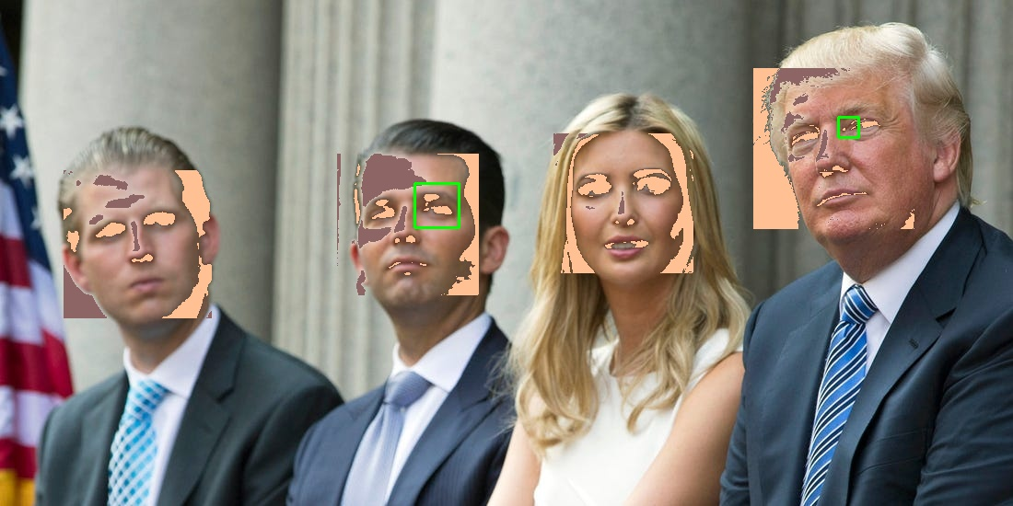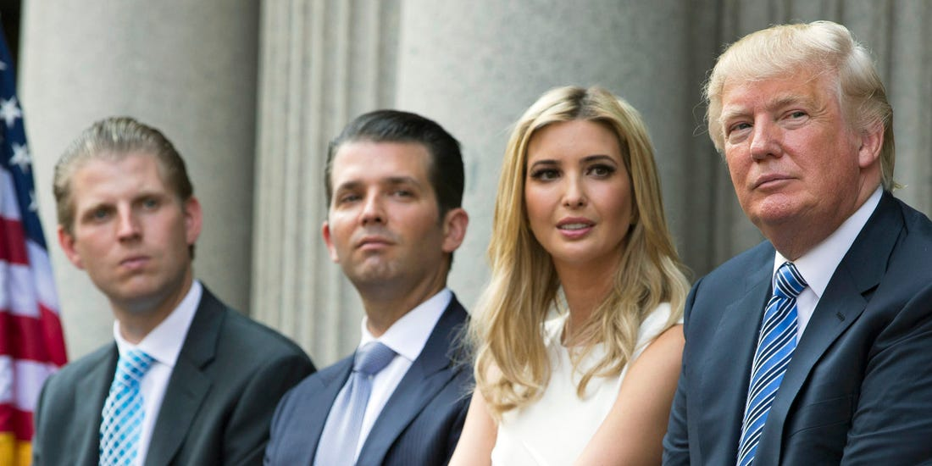

# Introduction

This project is motivated by the increase in the usage of automated image recognition algorithms (Parsania 2019). Especially China with its “Social-Credit-System” (SCS) drives this field of research. The SCS is national reputation system to monitoring its citizen and was developed by the Chinese government. In general, the SCs gives for each action of a citizen positive or negative points. Positives points can be collected by exemplary behaviour (e.g. to execute tax return in due time) and leads to social benefits (e.g. discount for the next train journey). Negative point can be collected as well (e.g. to drive over the crossing at red), but they can lead to harsh social consequences. If a person falls under a certain credit level due collecting too much negative points, the Chinese government is able to sanction the person (e.g. exclusion from public transport use). The usage of automated image recognition algorithms has not to end in a dystopia. A practical application is, for example, unlocking the screen by face.

A main goal in this project is to get a sense for face recognition. For this, the project is divided into seven tasks, which are conducted by different team members. Furthermore, the project is written in python and is based on the OpenCV package. Task 1 and 2 were done in group. They included to set up the structure of the code, implementing the received face detection algorithm and the validation of the algorithm. Task 3 was conducted by Kim Whett. The goal of this task was to improve the received face detection algorithm. Task 4 was conducted by Urs Gamper and included the measuring similarity between two pictures. Task 5 and 6 was conducted by Beat Furrer. First, a selective application of filters was set and second, adding at least one algorithm that leads to better blurring/ deblurring techniques or different filters. Finally, task 7 was conducted by Leonhard Rüegg. This task contained to add a GUI that allows the user to load an image, apply filters, chose different face detectors and save the output.

As mentioned before, OpenCV package is used for the face recognition. OpenCV is an open source computer vison and machine learning software library (OpenCV 2019). In General, OpenCV has learnt due machine learning some facial characteristics. The software “considers adjacent rectangular regions at a specific location in a detection window, sums up the pixel intensities in each region and calculates the difference between these sums. This difference is used to categorize the subsections of an image” (Poudyal 2018). In other words, the software recognizes the bright and dark differences on a picture around our eyes. Usually it is darker at the height of our eyes than above and below as well beside our eyes to the check. When these characteristics occur, the software recognizes the face and will draw rectangles around the faces.

The following link leads to the git-hub repository: <https://github.com/elBeato/pythonImagePrivacy>

# Overview of the code

The core of the code is the Python-File: main.py and its class Main(). The main.py imports the cv2 from OpenCV, the filters (filter_Task5) and the face detectors (face_Detect_improved1 and face_Detect_improved2). The class Main() starts the face detector. First, the image and the grad of boost is passed, which is needed to blur the image. Second, the in-function imread from cv2 reads the image and the cascade is loaded, which is used for detecting the faces in a first step. Third, the image is going to be blured and converted to the gray scale, so the OpenCV function is able to detecting the faces. Fourth, the triangles are drawn around the faces (if the faces are detected). In addition to the face detector, the eye detector is added by a separate file and which the Main() is able to load. Fifth, the GUI is implemented to give a user-friendly interface.

# Improving face detection algorithm (conducted by Kim Whett)

The improved face detection algorithm is not only based on the “haarcascade frontalface”, it is also based on the “haarcascade eye”. Both of them are trained files for detecting the face and eyes.

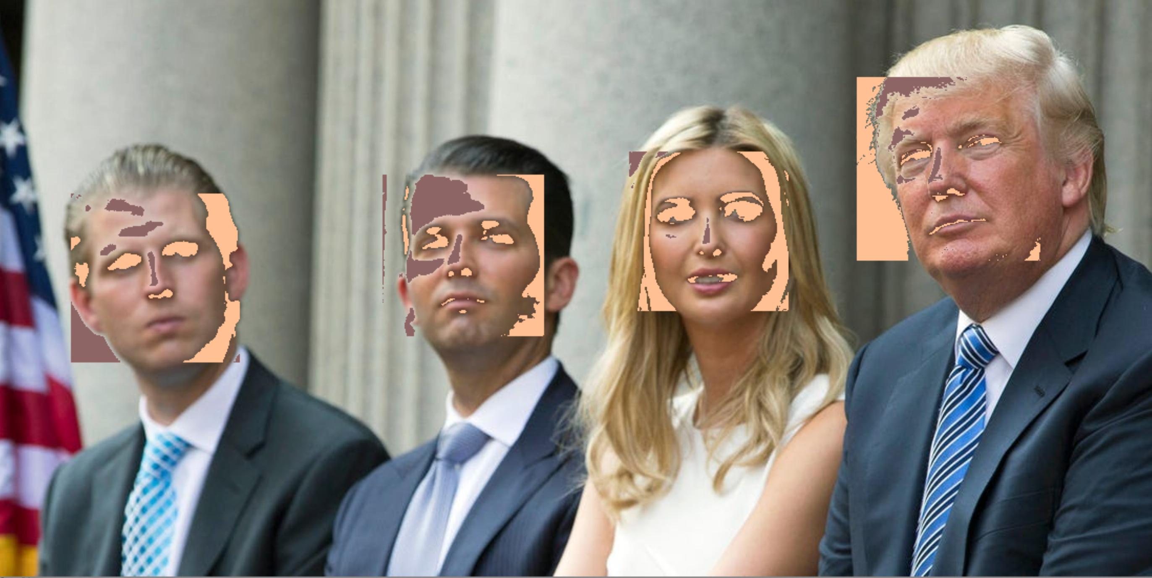

Figure 1: Coloured test picture with filter and the received face detection

Figure 1 shows the test picture and the filter, which was developed by Beat Furrer and will be discussed in the following section. It is obvious that the received face detection does not recognize the faces of the subjects on the test pictures. The mentioned rectangles are not drawn around the faces. The filter is therefore good enough to outwit the face recognition algorithm.

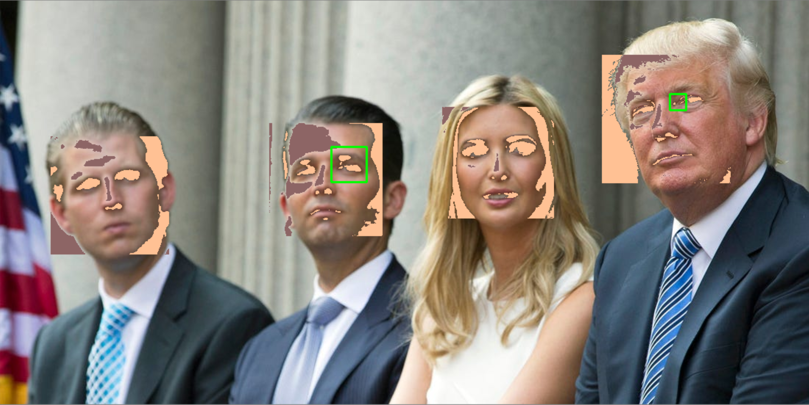

Figure 2: Test picture with filter and the improved face detection

Figure 2 displays the filter and the improved face detection. This detector can detect two eyes (green rectangles) in the filtered faces of the subjects. This underlines that the face detection has been improved.

In general, the eye detection recognizes eyes on a similar way as the face detection. A main criterion is that the area of an eye is darker than its surrounding. The Problem of this criterion is the high error rate, due to the high probability of darker areas with brighter surroundings. This is visualized in Figure 3. The eye detection is working by itself. This means with no further conditions.

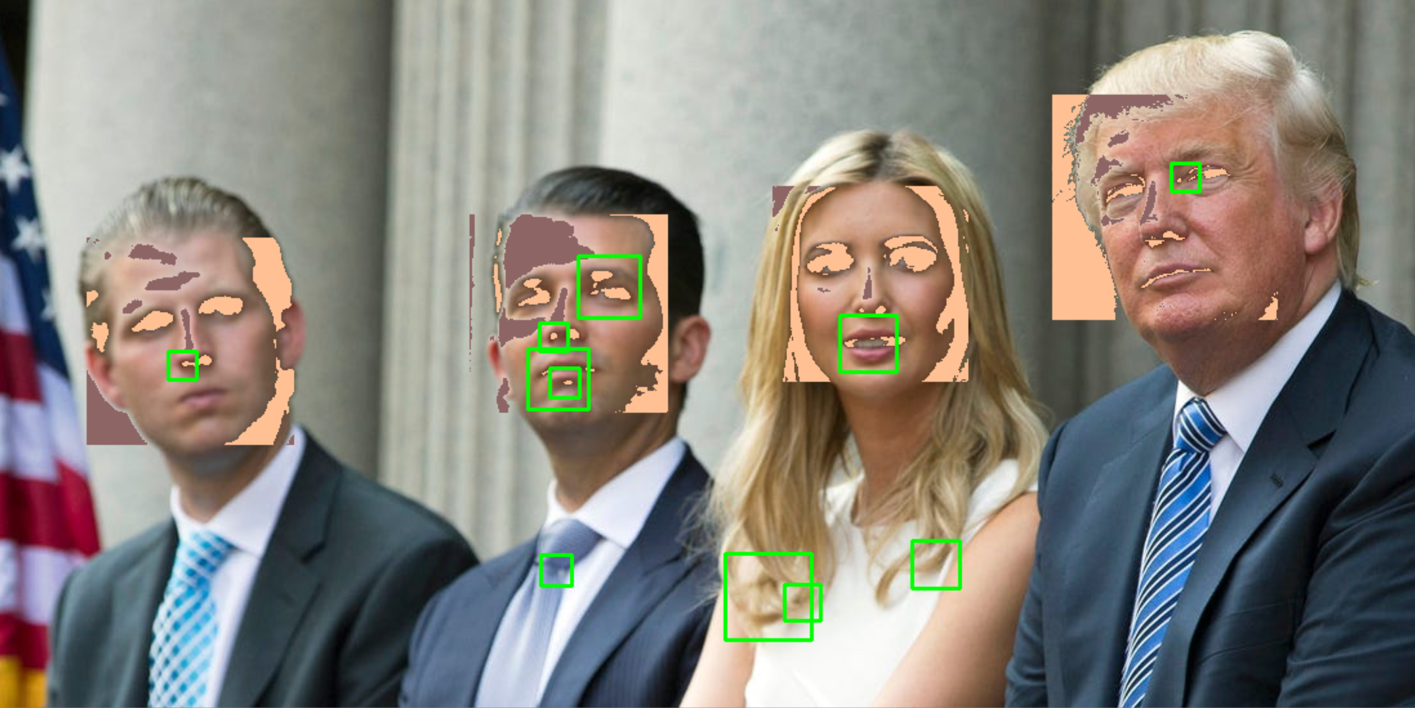

Figure 3: Test picture with filter and the self-standing eye detection

If the eye detector is not coupled to any condition, it recognized due to its high error rate several potential eyes, e.g. the tie of the second person from the left. To fix this problem the eye detector is linked to the following if-condition:

for (ex, ey, ew, eh) in eyes:

if (ex + ew) < (x + w) and (ey + eh) < (y + h):

cv2.rectangle(img, (ex, ey), (ex + ew, ey + eh), (0, 255, 0), 2)

else: print("eye not in face area detected")

Above is displayed a code-fragment from the class myFaceDetector2. If an eye is recognized in a picture the rectangle has to fulfil the if-condition. The coordinates of the eye-rectangle (ex, ey) as well as the hight and width of the eye-rectangle has to be in the face-rectangle. This is implemented by ex + ew < x + w and ey + eh < y + h. Other wise the statement “eye not in face area detected” is printed.

# Measuring similarity between pictures

If we consider images as one possible representation of a certain information, then there is a fundamental problem when trying to measure the similarity between pictures with conventional algorithms. The reason is that these algorithms only operate on this specific representation of the information (the image), whereas humans “see” the information behind the representation. An example would be Picassos bull.

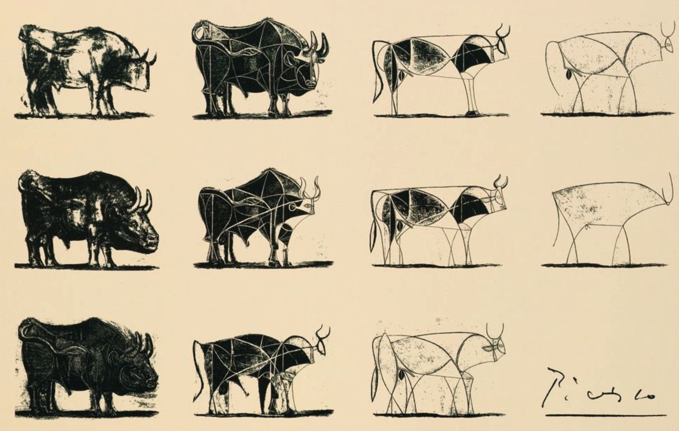

Figure 4: similarity between pictures

An algorithm relying only on the image representation of the information “bull”, will never be able to correlate the first to the last image without beforehand extracting the underlying information. To do this, we would need some prior knowledge and smart algorithms. (which was not done in this project)

Without prior knowledge we need to rely on “dumb” algorithms, operating only on the image representation without restrictions on the content of the image. We used three different metrics to assess image difference.

**Root mean square difference:**

If we consider the image as a vector with the intensities of all pixels as entries, then the root mean square difference is similar to the Euclidean distance between the vector of the original image and the vector of the filtered image. It tells you how much difference you can expect in every pixel *on average*. The difference is nomalized to 1.

**Maximum difference:**

This metric gives you the maximum pixelwise difference of the two image vectors. It gives you an upper bound of the difference you have in the images. The maximum difference is also normalized to 1.

**Binary metric:**

This metric ignores the actual difference in every pixel but only counts if the pixel differs or not. This gives you the percentage of pixels that have been changed.

All these metrices operate in image space, meaning they have the aforementioned shortcomings. For example, the rms error can become quite large if the modified image is only shifted by a few pixels. Therefore, it is worthwhile to consider other representation domains, for example Histogram domain, Fourier domain, Wavelet domain etc.

In this project we also added the histogram domain, since it should be quite robust to changes in the image like shifting or adding noise. Both changes that also don’t affect the human observer a lot. Before comparison, the images were transformed to histogram domain and then the same metrices can be applied as in the image domain. This is not ideal, since for comparison of histograms, there are more specialized functions (also implemented in opencv) that would make better use of similarity in histogram domain.

# Selective application of filters

After I organised the github.com repository and install all the gitextention application for easy use of git. I thought about, how I can apply a filter on faces. There is a point in the task 5 that bites itself. How can I apply a filter on faces without knowing were the faces are? To solve this issue, I can just apply a face detector or manually by a user.

Nevertheless, I started with a standard blurring filter to test the main functionality of the code. After that I catch up on the OpenCV2 face detector (haarcascade). I learned about his characteristics and tried outwit the detector. Haar cascade is a machine learning object detection algorithm which is trained on many negative and positive face images. The algorithm learned that are same darker parts at the eyes and some brighter parts forehead and some darker parts on each eye a brighter part between the eyes and so on. With these findings I implement a filter (two for-loops) to exchange the brighter with the darker pixels.

For me there were two challenging parts. The first one was to find good parameters that the algorithm doesn’t find any faces but on the other hand, the impact on the picture was minimal. The second difficult part was to apply all the filters on a coloured picture in which I was not successful in time.

# Adding at least one algorithm that leads to better blurring/ deblurring techniques or different filters

Beat prefers the filter with reflection of the bright (value >= 200) and dark (value =< 90) pixels at the mean of 127 the most. For example, if a pixel had the value 25 then the filter changes the value of the pixel to 230.

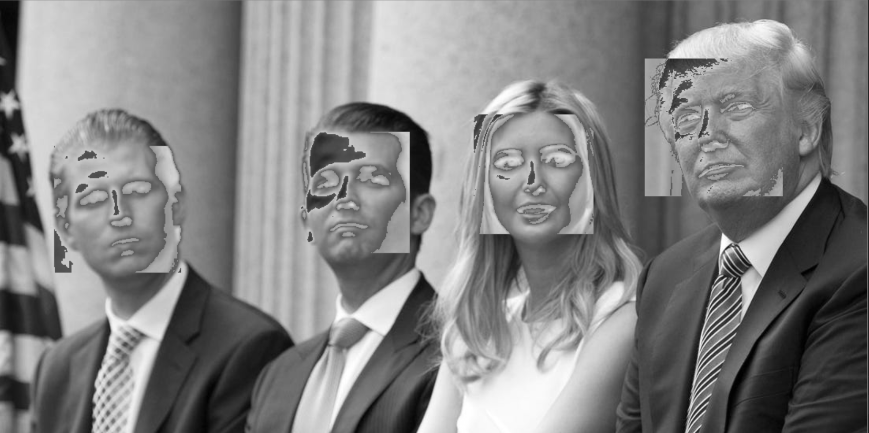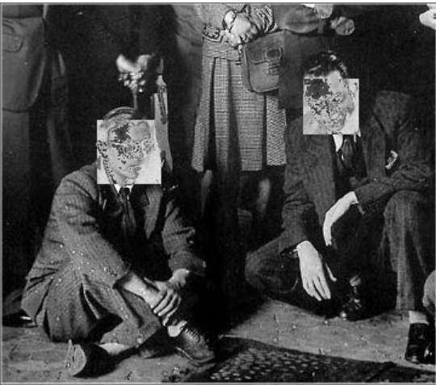

Figure 5: Filter 1 - beatFilter(self, image, dunkel=90, hell=200)

The second one is a gaussian pixel shift of all pixel. It looks like a sandy surface.

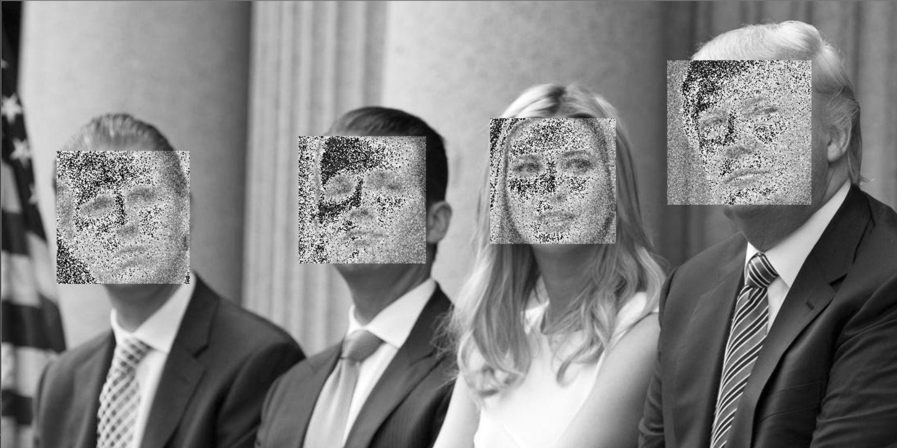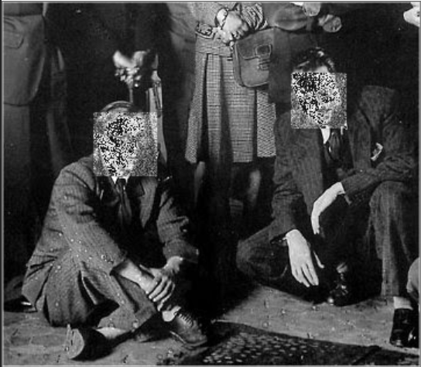

Figure 6: Filter 2 - applyPreventFD(self, bild, grundwert=65, abweichung=35)

After all the last on is quite primitive. The filter exchanges every second pixel to a black (value = 0) one. It depends on the image how good the filter works. At the Trump family you can see that the filter just performs well on two faces, but for the users the filter damages the picture less.

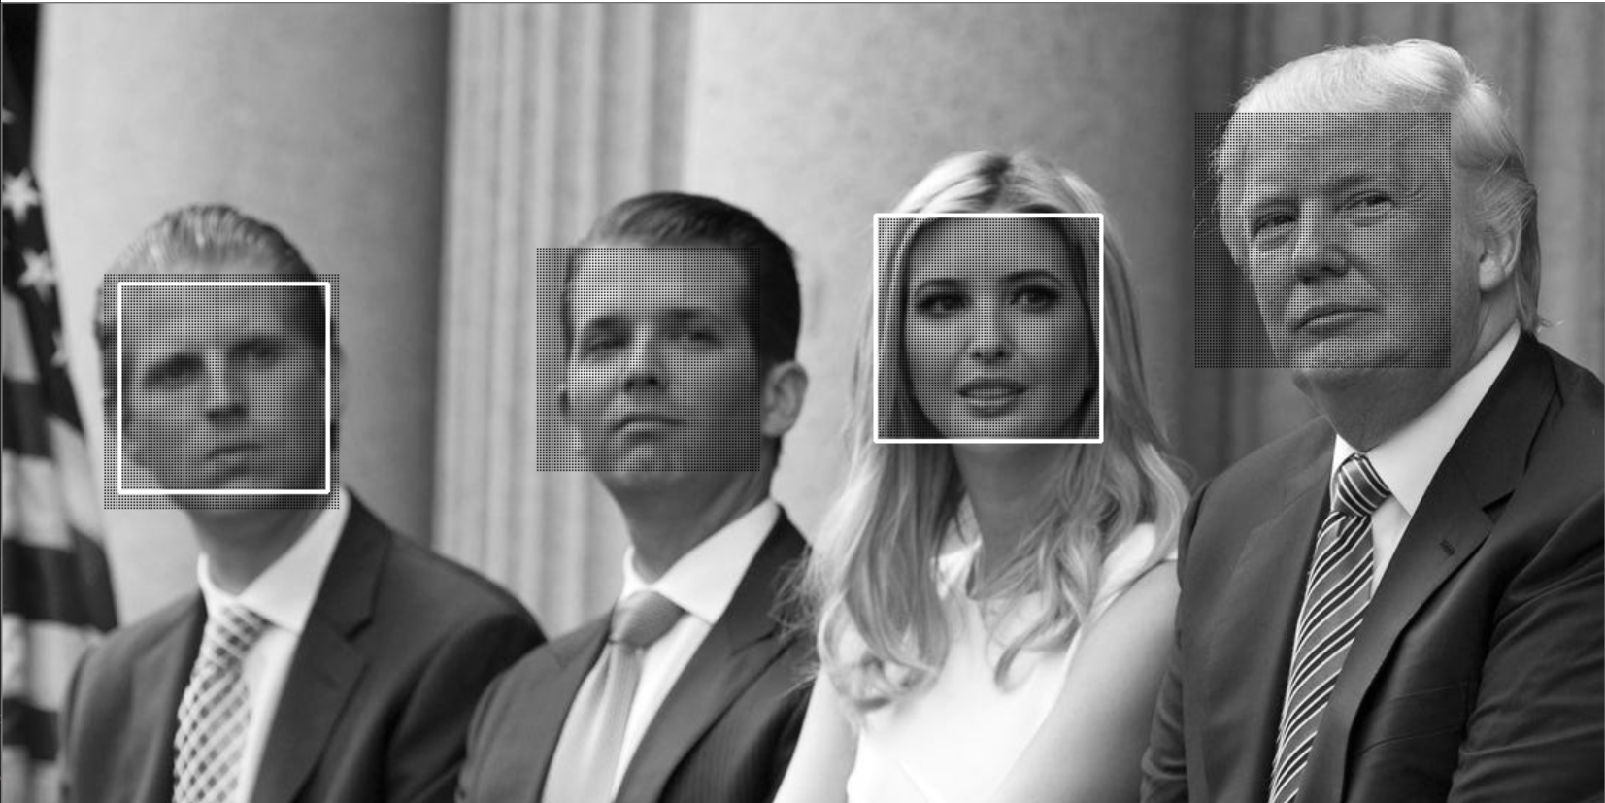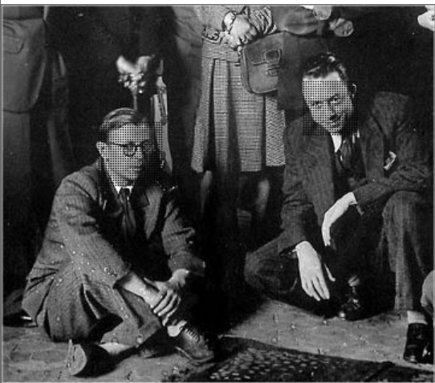

Figure 7: Filter 3 - shiftPixels(self, crop_img)

# Add a GUI that allows the user to load an image, apply filters and save the output

My task was to figure out how we could implement all our divided efforts in one user-friendly program. After some research, I realised that the PyQt-Library seems to be the current best practice for making user interfaces in python. Probably the best thing about PyQt is the QT Creator software. This standalone application is very useful for quickly sketching an interface.

1. 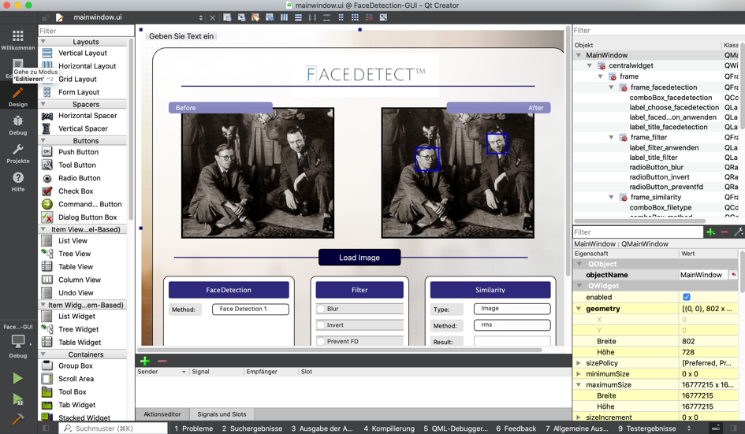

Figure 8: QT Creator allows the user to quickly design an interface

But QT Creator doesn’t make it all easy. QT Creator relies heavily on the programming language CSS, which I was totally unfamiliar with at the time. So, in order to change colors, style etc. of the user interface, I had to teach myself some basic CSS-skills. After some research, I was slowly getting a general idea on how CSS works and was also able to implement some details into the design of our user interface. One of which is the hover style on the main buttons. This makes for a pleasant effect, as the buttons change their looks when the user moves his cursor over it.

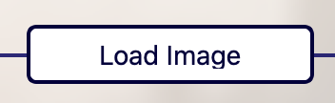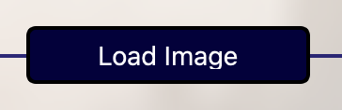



Figure 9: A simple but effective CSS trick allows buttons to change their style while the cursor is moved over it

After figuring out how to set up and design a basic user interface, I quickly was faced with the real challenges of my task. The first problem was to implement the user interface I created in QT Creator into my python script. At first, I thought this was something the library would take easy care of, but sadly, it wasn’t as intuitive as one might could think. The problem was that the file created with QT Creator wasn’t compatible with python from the get-go. Only after researching for quite some time I finally found the solution. The key was a simple terminal command that allows to convert the QT Creator-File into an equivalent that can be imported into python. Accompanied by a sigh of relief, our interface finally displayed from my python IDE.

The second challenge was to connect all the buttons from the user interface to the python code and allow the user to load up an image. Each element of the interface has to be defined and connected to a function. The function in this case is the event that should happen once the element is used. For loading an image, I created a button that is connected to a function that allows the user to search through his directories and select an image. This image was then displayed on the interface.

The third and last challenged proved to be the most difficult. As my colleagues finished their respective tasks, it was time to bring all our efforts together. At first, I thought this shouldn’t be too much of a challenge – I was dead wrong.

I checked in beforehand that the opencv library we use for the facial detection works on the same python version as PyQt library. Nonetheless, when I implemented the opencv into our interface, the program continued to crash. Then I figured I could just transfer my interface to python version 3.6, as I knew that the opencv library surely will work there. But for some unkown reason, PyQt currently isn’t supported in python 3.6. After a cumbersome internet research, I found a solution. The key was to install the opencv library not through the pycharm packages section, but directly through the terminal.

After the opencv and PyQt library finally worked in harmony, I started to connect the various functions my colleagues created with our interface. Our goal was to combine all our functions into one file of code. This proved to be problematic, as my approach for letting the user load up an image treats images differently than the functions of my colleagues. The resulting conversion issues quickly became tedious and confusing. Adding to that, my decision to use global variables made things worse, as different functions used the same variables but manipulated them in different ways and therefore formats.

After a lot of hours spend, we sadly didn’t manage to get all our function working properly in our interface. A valuable lesson learned is that file and variable formats should be agreed on in beforehand. Also, global variables shouldn’t be used – how ever tempting it might could be.

# List of References

OpenCV (2019): *About*. https://opencv.org/about/. Access at 12.10.2019.

Parsania, Asieh (2019): MAT 101: *Programming. Group Projcet: Towards image privacy*. Universität Zürich: Zürich

Poudyal, Rabin (2018): *Real time face and eyes detection with OpenCV*. https://blog.goodaudience.com/ real-time-face-and-eyes-detection-with-opencv. Acess at 12.10.2019

# List of Figures

Figure 1: Coloured test picture with filter and the received face detection 3

Figure 2: Test picture with filter and the improved face detection 3

Figure 3: Test picture with filter and the self-standing eye detection 4

Figure 4: similarity between pictures 5

Figure 5: Filter 1 - beatFilter(self, image, dunkel=90, hell=200) 7

Figure 6: Filter 2 - applyPreventFD(self, bild, grundwert=65, abweichung=35) 7

Figure 7: Filter 3 - shiftPixels(self, crop_img) 8

Figure 8: QT Creator allows the user to quickly design an interface 8

Figure 9: A simple but effective CSS trick allows buttons to change their style while the cursor is moved over it 9